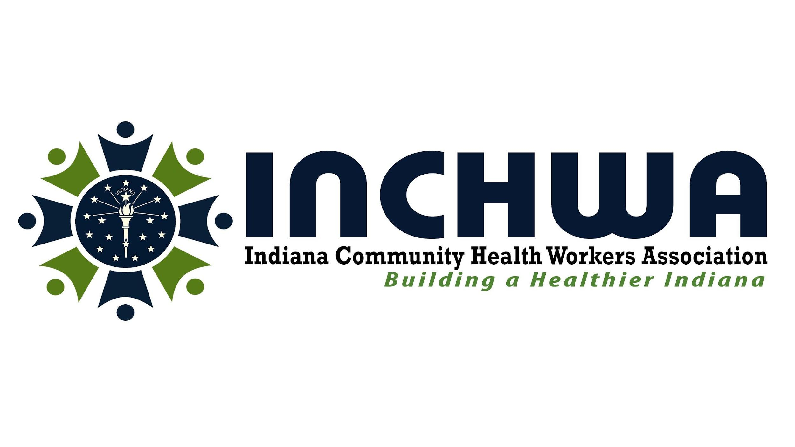
Invoice

Your Address  City, State, Zip  Phone: 123-456-7890 | Invoice # 100-Organization  Date:
Contact:  Name  Title  Organization | The Indiana Community Health Workers Association (INCHWA) provides strategic support to partners by enhancing the reach and impact of their services and products within underserved communities across Indiana.
Product and Service: Strategic Investment Partnership
Strategic Collaboration to promote projects leveraging the skill set of the Community Health Workers in the community and/or the organization through INCHWA.

Select Type of Partnership | Type of Partnership | Services | Cost | Amount
 | Partnership for two-time promotion of Project | Two Announcements/Surveys | $250
 | Yearly Partnership for on-going promotion of partnership | Announcements/Surveys | $500
 | Yearly Partnership for on-going promotion of our work | Job postings offering compensation exceeding $22.00 per hour, Projects compensating below $22.00 per hour, Team meetings, Announcements and Surveys. | $1,000
 | Yearly Strategic Project Partnership | A strategic partnership designed to support the Community Health Worker workforce through monthly grant project consulting (up to 3 hours) and targeted promotion of the initiative to enhance visibility and community engagement. | $6,000
 | Other Partnership | Services defined through a partnership agreement  Contact us for Discovery Call  incommunityhealth@gmail.com | Negotiated
Please make check out to:  Indiana Community Health Worker Association  Address: PO Box 7098, Greenwood IN 46142 |  |  | The Total for my Partnership
Instructions: Fill in the highlighted sections and indicate the level of partnership you wish to commit to, and complete the total. You will submit this invoice to your accounting department and email us a copy of it at incommunityhealth@gmail.com

